

A guide to searching the Library Catalogue

Getting the most from your searching

The London Library Catalogue can be used to search both our print and online holdings, as well as allowing you to manage your Library account, reserve print items, save records and build book lists. To access the Catalogue outside of the Library, go to www.londonlibrary.co.uk and click the ‘Search the collection’ link at the top of the page. Navigation is menu-driven and hovering with your cursor over an icon will display its function. The default Catalogue will show both physical and online resources so if you are only interested in physical items, either use the Print Only version available at the top of the homepage or limit your search to Library catalogue.

- Signing in

When you open the Catalogue, it is always advisable to sign in to your Library account. This will grant you automatic access to our online resources and ease the process of requesting books and saving item records.

- Click the  icon in the right top-hand corner of the page.

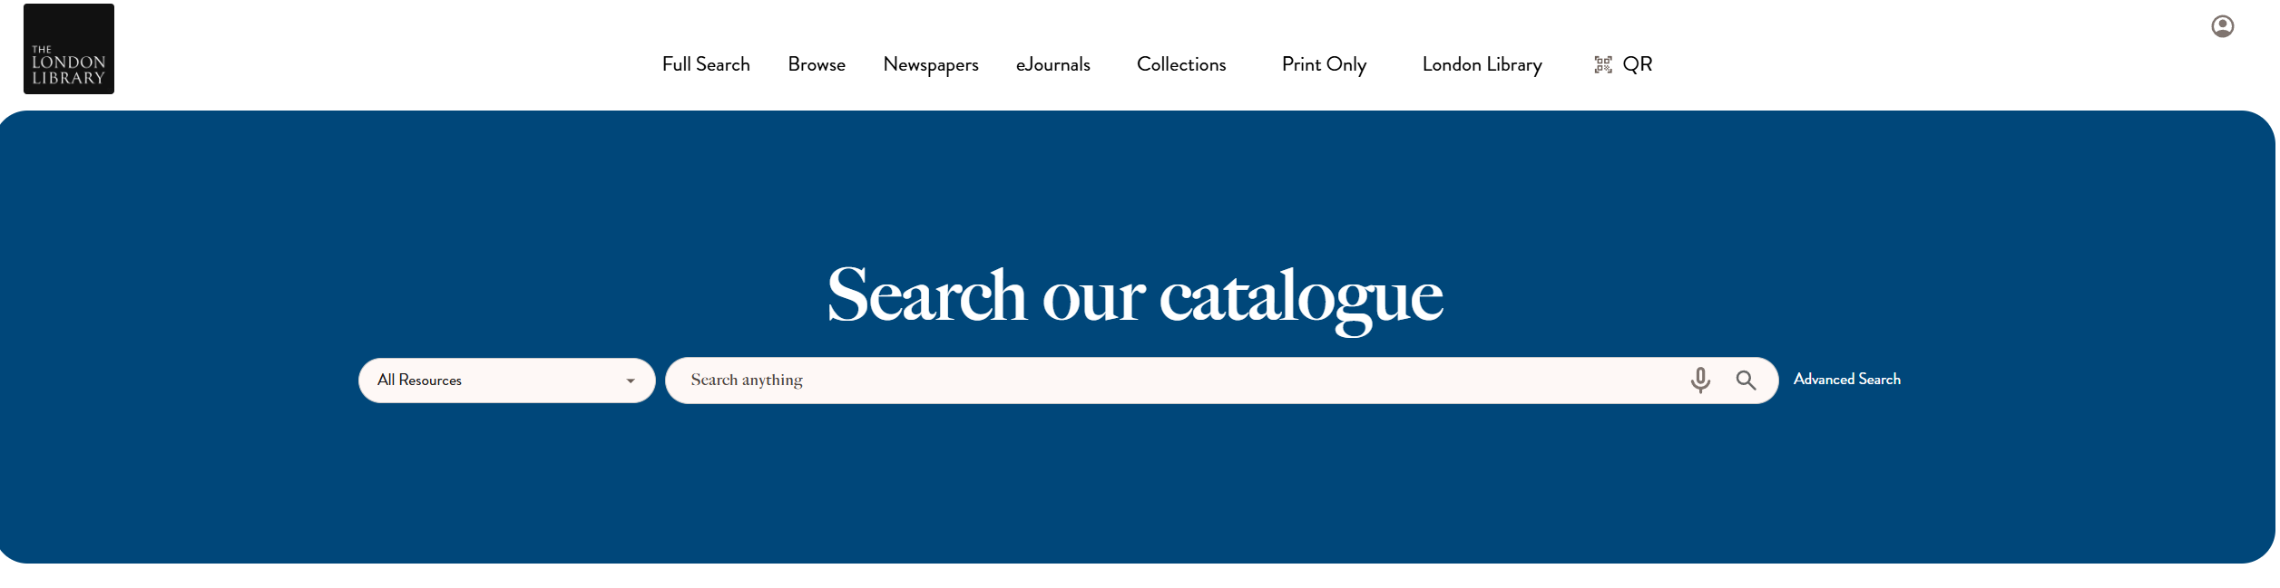

- If you are using a Library PC or another public computer, make sure you always sign out again by clicking on your initials in the top-right hand corner of the screen, selecting Sign Out and closing the browser.

- Managing your account

The account area of the Catalogue allows you to manage and view the history of your library account yourself. Here you can check which books you have on loan, renew them, see a list of your previous loans and check the progress of any requests you may have made. If you see something on your account that looks amiss, you should contact the staff at the Issue Desk.

Once you have signed in to the catalogue you will see the icon has been replaced with your initials (reversed). Clicking on this will produce a drop-down menu with options to help you manage your account.

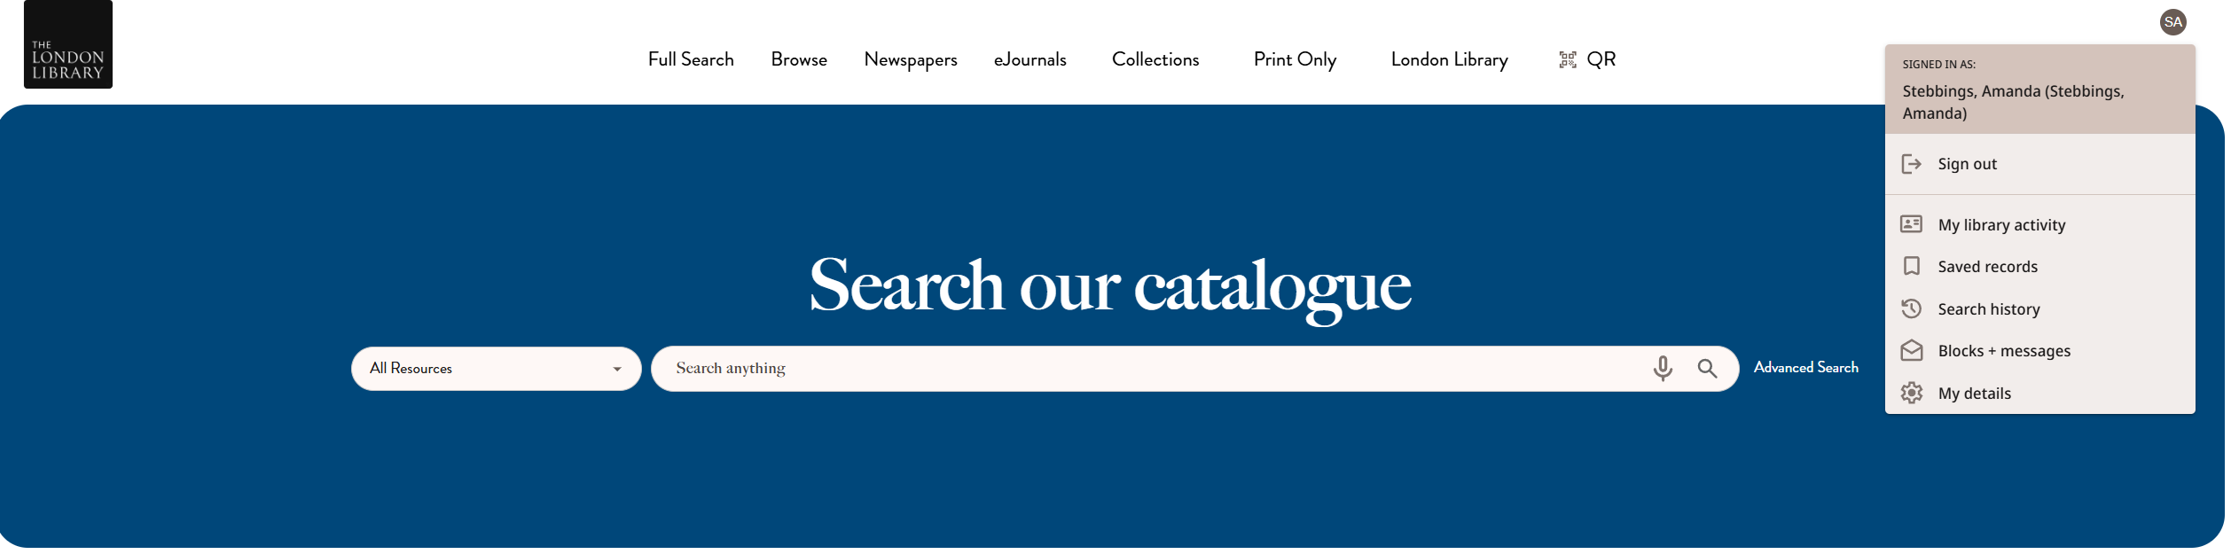

- My library activity – gives an overview of your library account
- Saved records – shows you the item records you have chosen to bookmark
- Search History – displays a list of the searches you have run in that session
- Blocks + messages – displays any problems on your account or any messages
- My details – shows the contact information the Library has for you

Renewing your Loans: Unless recalled by another member, your loans will automatically renew. The Library does ask that books be brought in once a year so that their condition may be checked.

Viewing your current loans: To see the list of books you currently have on loan, from the My library activity screen click View all loans at the bottom of the Loans box

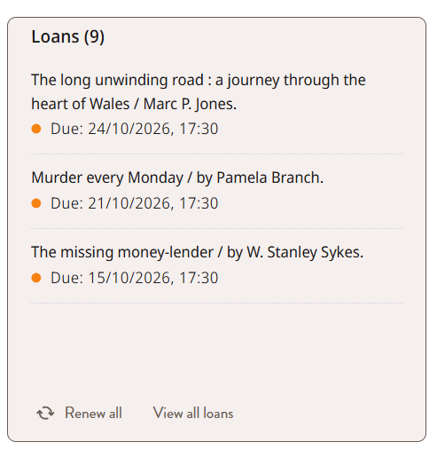

The subsequent screen will show the full list of current loans.

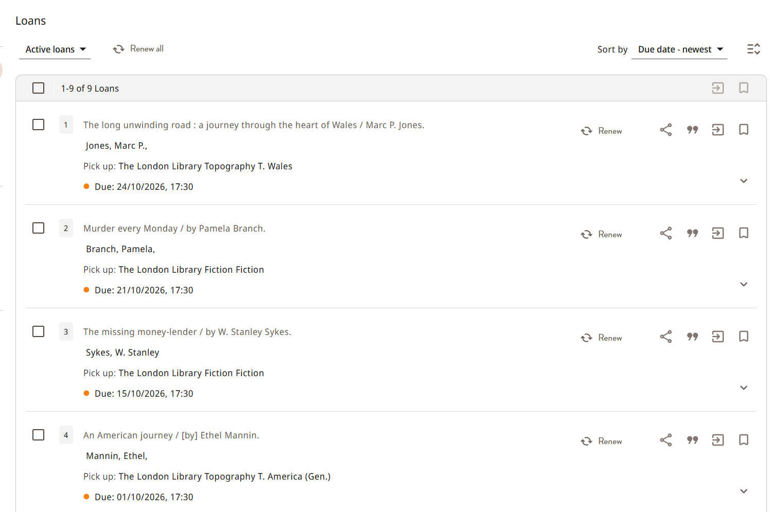

If you wish to view a list of items you have borrowed previously, click on Active Loans, displayed at the top of the Loans page. This will generate a drop-down menu. Click on Previous and Historic Loans and you will see the list displayed now changes to show a list of items you have previously borrowed and returned, starting with the most recent. Please note that this list only covers items returned since January 2021.

Clicking the arrows next to each item will display the full details of the loan. You can rearrange the results using the Sort by drop-down menu at the top of the list.

Viewing your Requests: You can view your active requests from the Requests box on the My library activity page. The Requests page will list any active requests and whether or not they are ready for collection. An item will show as In process if it has not yet been fetched from the shelf. Not started means that the item is on order, on loan to another member or that you are in a queue. If the item is ready for you, the date of its last day for collection will be displayed. You will also be given the option to cancel requests you no longer need, although please note that if the item is already awaiting collection, it will need to be removed from the shelf onsite before it disappears from your list.

- Searching the catalogue – Simple Search

You can use the search bar on the Catalogue homepage to conduct a basic keyword search. This will return a list of all items, including online resources and articles, where your keywords appear anywhere in the item’s catalogue record.

When you begin to type your terms, the Catalogue will suggest terms which may or may not be of use. Either continue entering your search terms or choose one of the suggestions, then click on the magnifying glass at the end of the search bar.

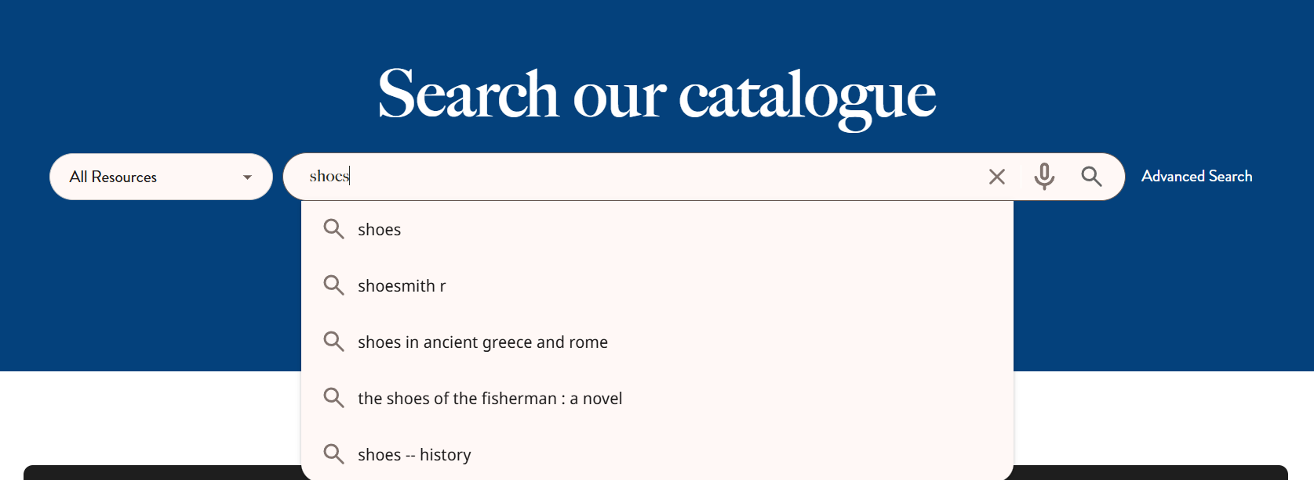

If your search terms are quite general, a lot of results will be generated as by default the Catalogue will conduct the broadest search of the collection. However you can narrow your search to selected areas of the collection or material types by using one of the options from the drop-down menu to the left of the search bar.

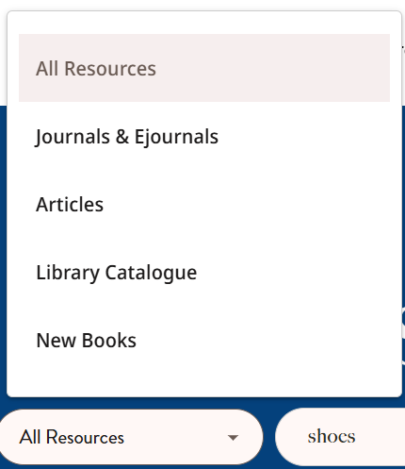

- All Resources – the broadest search which will return results from all material types, both physical and electronic
- Journals and eJournals – displays records of journals, magazines and periodicals, both in print and online, that contain your search terms in their titles or bibliographic information.
- Articles – displays any articles found in our online resources matching your search terms.
- Library Catalogue – displays physical book and journal items only
- New Books – displays print items acquired by the Library in the last 4 months.

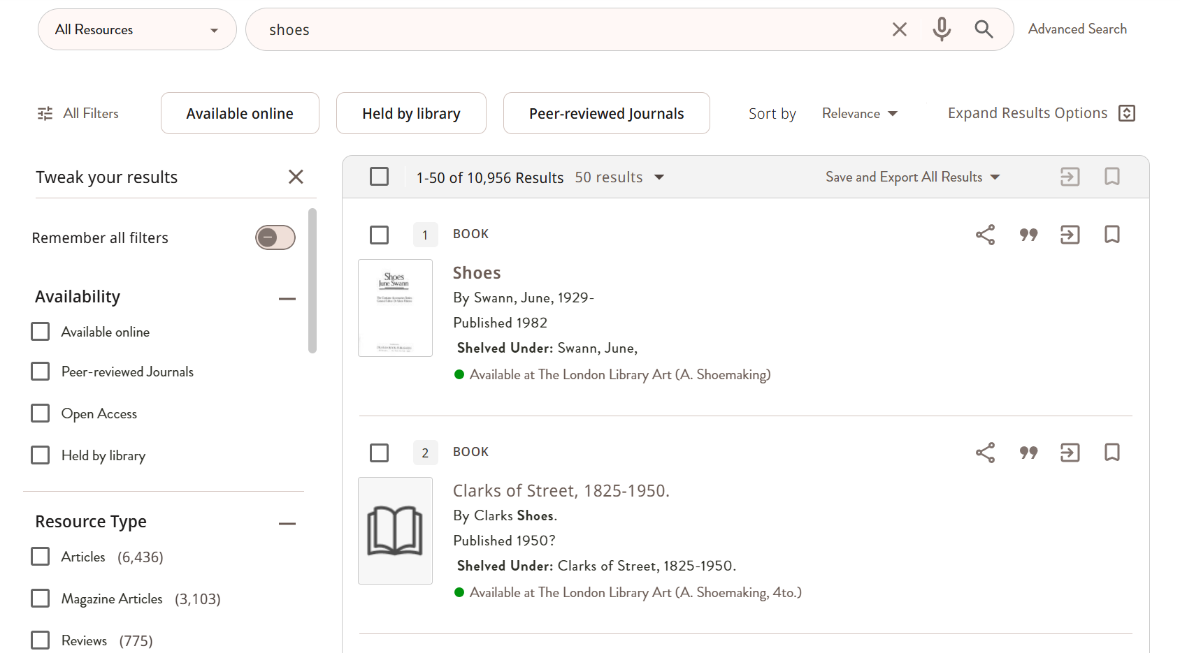

The most popular filters are displayed in the row above the search results but many more can be found to the side of the screen. You can use the refinements on the left-hand side of the screen to narrow your search results further. Please note that Location refers to the different London Library collection areas (for example, History or Science and Miscellaneous). By default results are displayed according to relevance but you can change this by clicking on the drop down menu next to Sort by. Clicking on Expand Results Option will widen your search to return relevant items to which the Library may not have access.

Click on the plus sign to expand each filter and see the different options, then click on the box to the left to include that option, or the crossed-through box on the right to exclude it. When you have chosen your filters click on the Apply filters button.

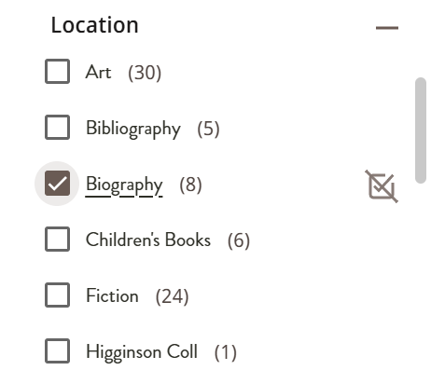

Following some of the tips below will help you to construct a search that returns a more relevant set of results.

Phrase searching
This is particularly useful if you are looking for peoples’ names or looking for popular phrases. Enclose your terms in double inverted commas, for example, “global warming”, “Edward Lear”. Doing this ensures that you will only get results where the two words appear together.

Boolean searching
You probably use Boolean searching every day without realising. This type of search uses three operators AND, OR and NOT (always typed in capitals) to create different types of searches. A regular keyword search on most websites assumes you have put AND between each of the words.

Using OR will expand a search to return results containing any of the terms you have specified. For example, Shakespeare OR sonnets will return all results for Shakespeare or sonnets, including sonnets that are not necessarily by Shakespeare.

Using NOT will reduce your list of results by excluding the terms you have specified. For example, Shakespeare NOT sonnets will return all results for Shakespeare but exclude those mentioning sonnets.

Truncation searching
If one of your chosen terms could have a number of different word endings, you can use a truncation search (also known as a wildcard search) to include them all in your search. Simply put an asterisk * at the end of the root of the word. For examples shoe* would return results that contained shoe, shoes, shoemaker, shoemakers, shoemaking etc.

You can also use a ? to replace a letter within a word. For example wom?n would return results containing woman or women.

Putting it all together
It is possible to combine a number of these techniques to create a very focused search. For example, you may be interested in the writings of people who have travelled to India and produced diaries or memoirs. Creating a search string which uses truncation, Boolean and brackets to combine Boolean terms, you can retrieve a very focused set of results.
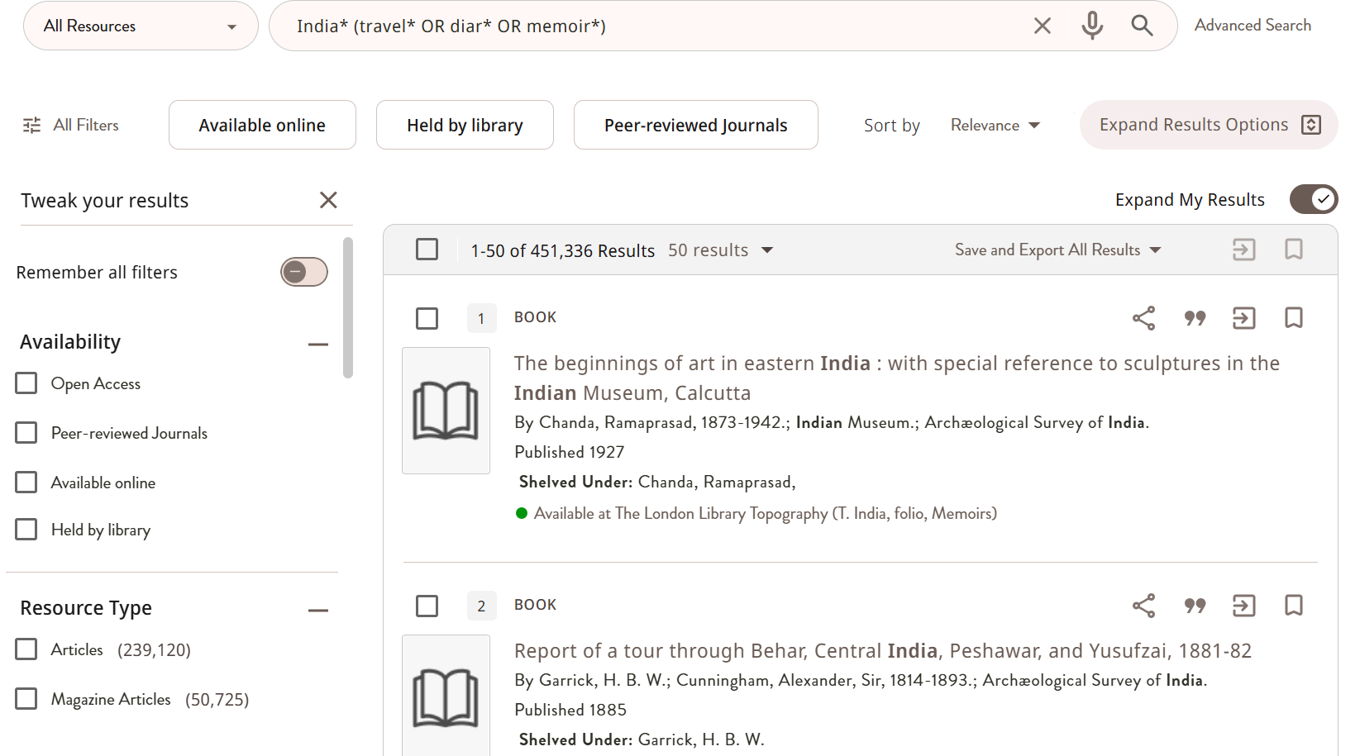

- Searching the catalogue – Advanced Search

If you wish to generate a more specific set of results you may wish to use the Advanced Search. This is useful if you wish to see what sort of books and resources we might have relating to a particular subject or by a specific author. It is also useful in pinpointing whether or not we hold certain editions of a text.

You can switch to the Advanced Search page by clicking the option at the end of the basic Search bar.

You will see that you are now presented with several options to help you search. By clicking the Any field menu, you will be presented with options as to where you want the catalogue to look for your search terms. Some of the most useful options to take note of are:

- Author/Creator – This will return items where your search term is listed as an author or editor of a work.
- Title – This will return items where your search term appears within the title field.
- Subject – This will return items where you search term appears in in the subject fields of their records. Most items will have multiple subject fields so it may be beneficial to use additional lines of search (see below). For example, a subject search for ‘History’ will return every book classed as being about history, but adding another line that says ‘20th Century’ as a subject will return books where both of these terms appear to give you a list of items related to 20th Century history. This search is best used for searching for items on specific topics.

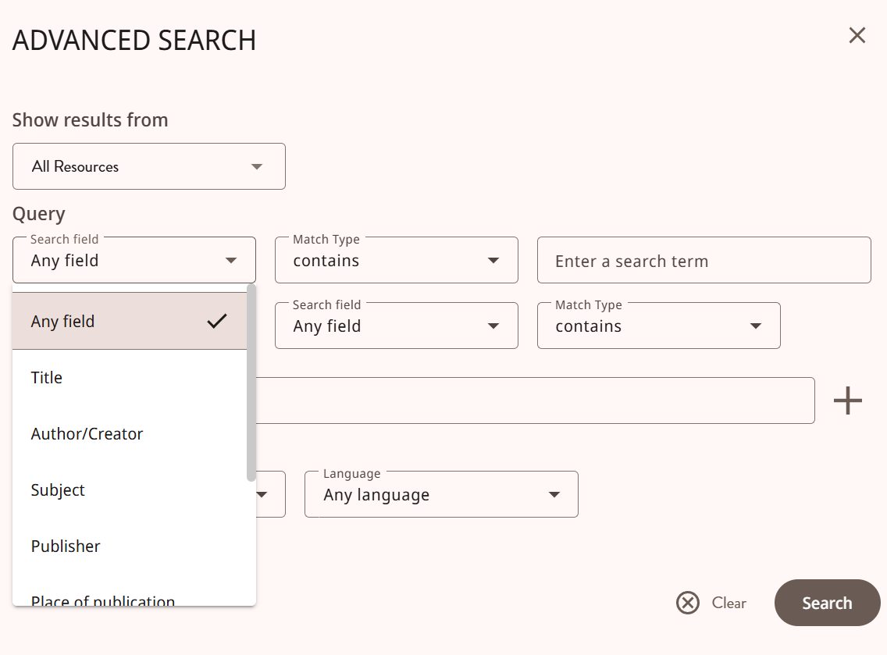

By default, you will be given the option to search two fields at a time at a time. This is useful for running searches for a specific item, using Title and Author options or for running subject searches as detailed above. If you wish you can add further lines of search options by clicking the plus sign. The more lines of search you use, the more specific your results will be. The search scopes appear at the top of the page if you wish to limit your search to certain areas of the collection such as new books.

Scroll to the bottom of the Advanced Search box to find options to narrow your results by Material Type, Language and Date.

Once you are happy with your specifications, click Search. Your search terms are displayed in the bar at the top of the page and should you need to make amendments you can use the Edit option or switch to a Simple Search instead.

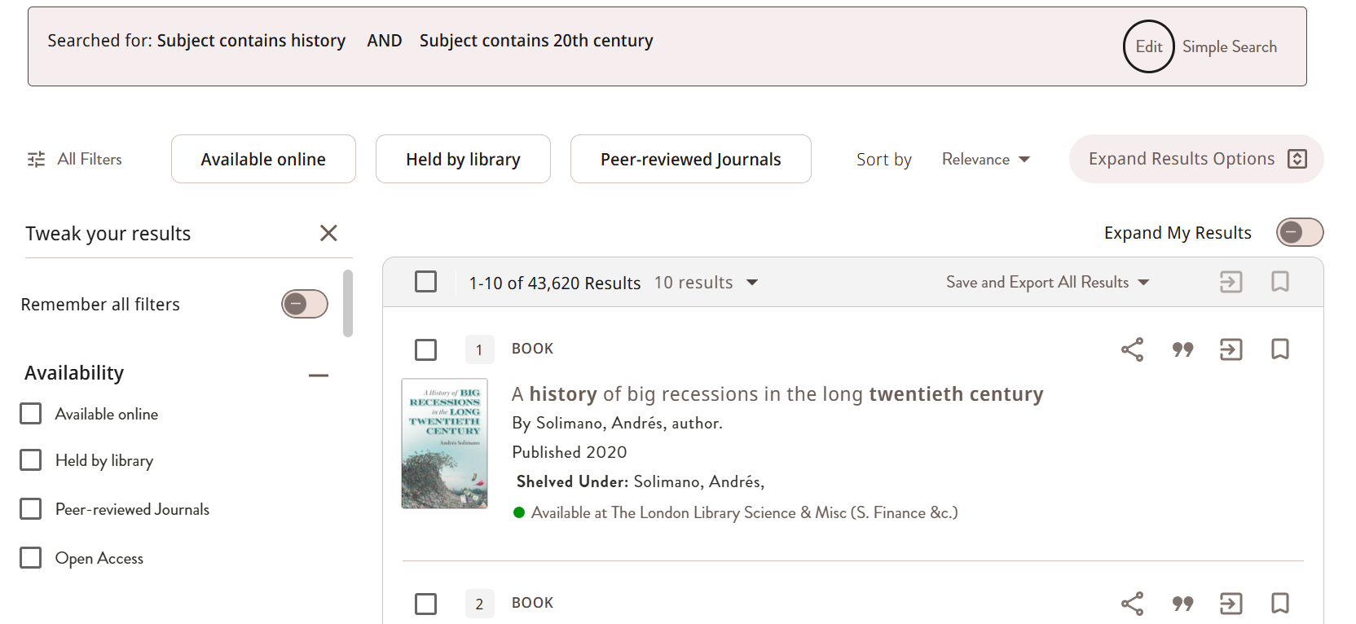

- Understanding your search results & finding books

A search on the Catalogue will return a list of results. These brief records should contain enough information for you to identify and locate the book in the Library. If you are planning to come to the Library and find the item yourself, make sure that it is listed as being Available. If the book is on loan it can be recalled from the member who has it using the catalogue (see 6. Requesting Books).

Next to the availability indicator, you will see the item’s shelfmark in parentheses. You can use the Library Floorplan to locate where your item will be or ask a member of staff during your visit. Pay close attention to any shelfmarks ending in 4to., folio, or sm. folio. These abbreviations indicate that these are larger items and so will be shelved away from the standard size books in this sequence, although usually they remain nearby. Staff will be able to advise you on where to find the 4to. or folio sequence for each shelfmark.

If you see a shelfmark that doesn’t appear on the floorplan, it is likely that this item is stored in one of the Library’s Special Collections. Some items in Special Collections can be reserved through the Catalogue but particularly rare items will not give you this option. Instead the Catalogue will advise you to contact Library staff to arrange for them to retrieve the material for you.

You should also make a note of how the item is shelved within the shelfmark. The majority of books will be shelved alphabetically by the author’s surname, but edited works are shelved alphabetically by title. If an item is shelved by title, please ignore any articles at the start of the title.

In the case of online articles or resources, instead of the availability indicator you will see the words Available Online. As long as you are already signed into the catalogue, clicking here will open the full record with the article details. Scroll down to View Online and click on the link to access the article. Please note that while most links will take you directly to the article, some publishers will take you to the homepage for the journal instead.

To access the full record simply click on the title within the brief record and you will see further details and the option to request the item. Many full Catalogue records will contain subject headings. These are very useful in identifying titles that match your search criteria but may be shelved elsewhere in the collection. Click on the subject heading to retrieve the list. Under Links you may find more information about the book such as an abstract or a table of contents. The Virtual Browse feature at the bottom of the record shows you the books in the same section and allows you to browse the shelves as if you were in the building. Click on a book image to view the full record.
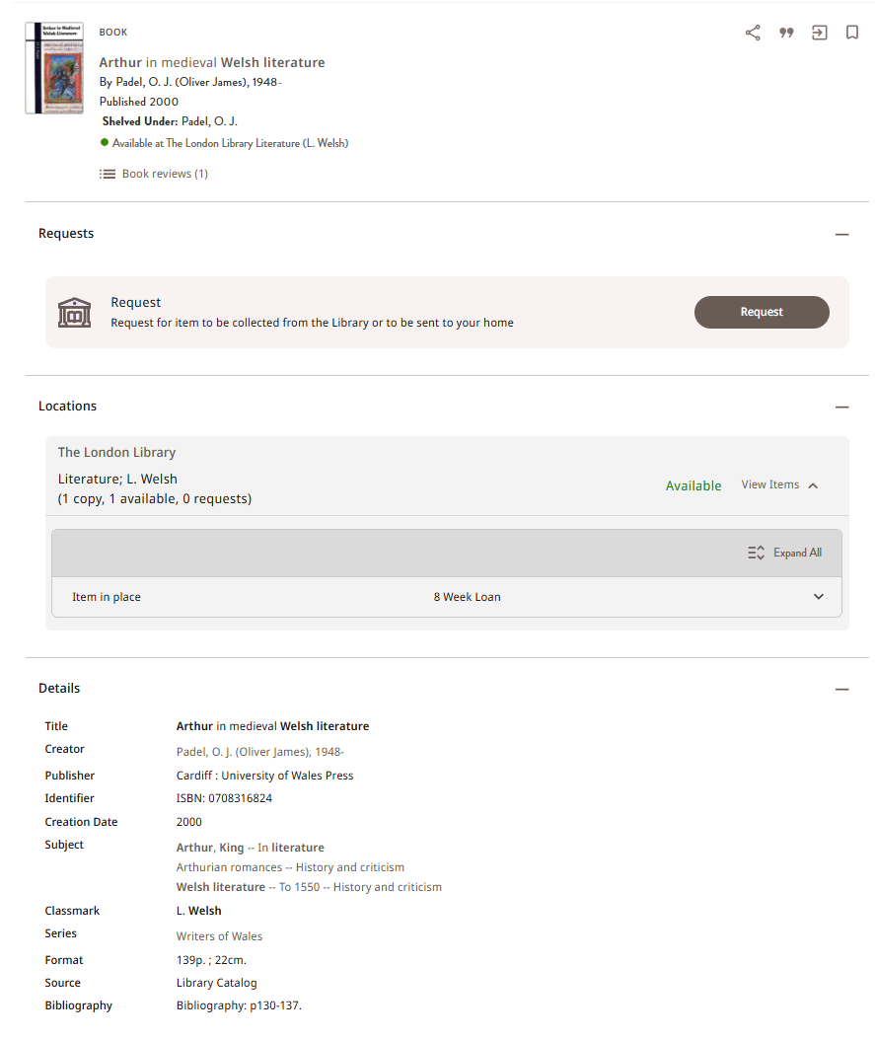

- Item records & requesting books

Books can be reserved or recalled from loan through the Catalogue. We aim to retrieve books that are available on the shelves within 48 working hours of receiving your request so it’s advisable to make sure you allow enough time when submitting your request. Some journals are now stored offsite so please allow 48 working hours for these to be retrieved.

To request a book:

From your search results, click on the title of the book to go to the full record, then click the Request button, which can be found under the Requests section of the record.
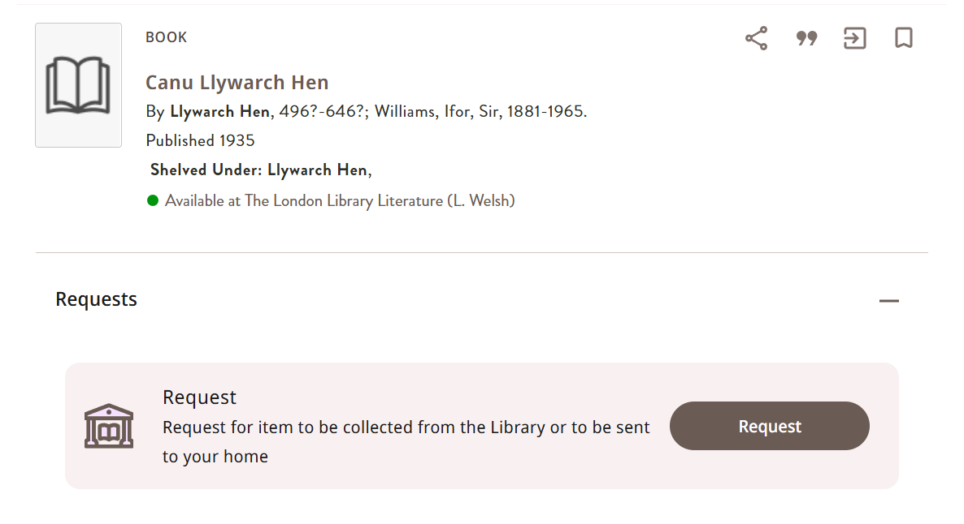

You will then be asked whether you want to collect the book from the Library or have the book sent to you through the post (with additional charges for postage).

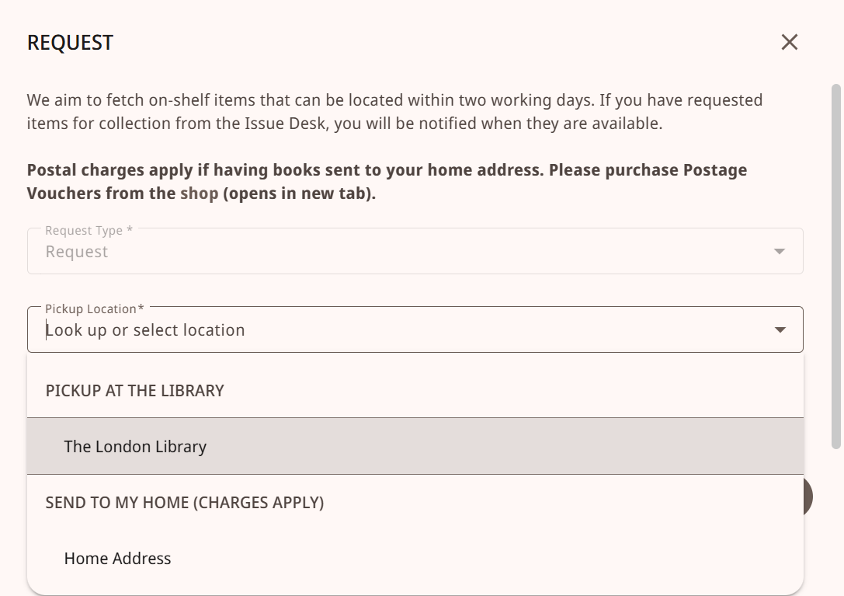

We aim to fetch items on the shelf within 48 working hours of receiving your request. You can use the Comment field to tell us if the request is urgent (maximum 50 characters). Click Send Request to complete your request.

Once the book is available we will let you know by email that your book is ready for collection and you can see the progress of requests by checking your account.

- Saving items & searches

Saved records is a very useful tool for bookmarking the records of items you may wish to revisit or cite at a later date, and for saving searches that you may need to re-run in the future. It can be used to organise your resources into sections, build a bibliography, print, share and export records. If you are planning to use this feature, always make sure you have signed into your Library account first otherwise any items or searches you save will be lost when you close your browser.

To save the record of an item click the bookmark icon next to the record you wish to save.
- 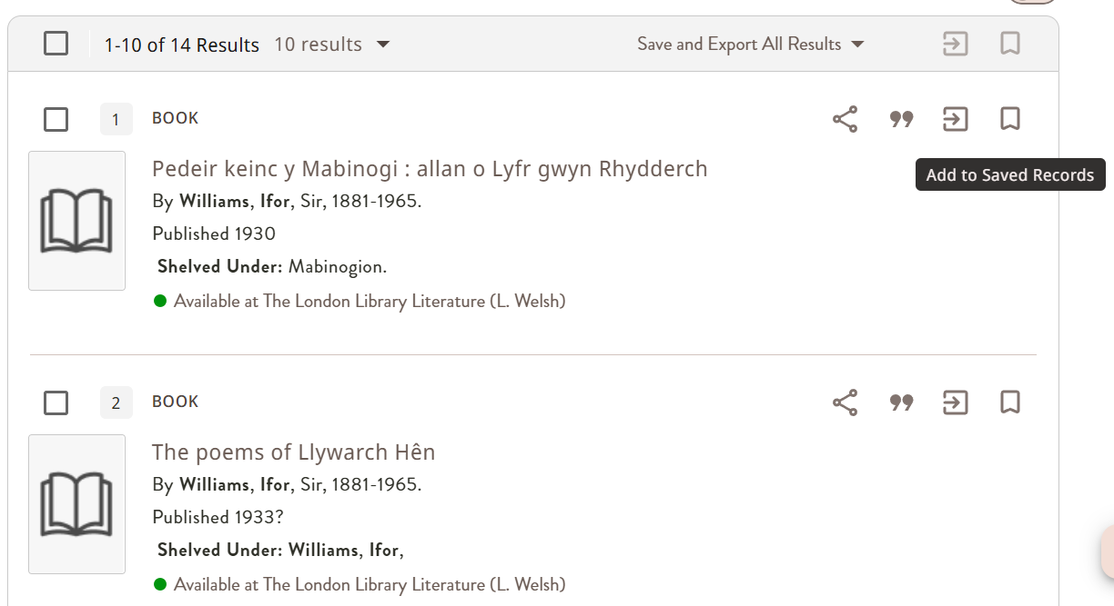

To view any records that you have saved, click on your initials in the top right-hand corner of the screen and choose Saved records from the drop-down menu.
If you are working on multiple projects, you may wish to separate out your list using Labels. To do this, check the number box of the item you wish to label and click Add new label. You can choose to add the item to an existing label or create a new one. If you are adding a label for the first time enter the name of the label and click on Create new to save your new label. Once you have added the label it will appear on the drop-down menu.

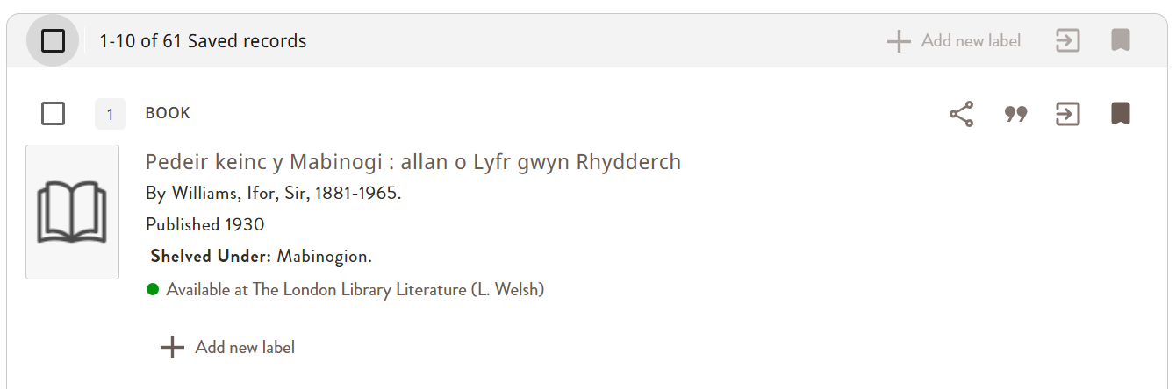

To view the items you have saved to a particular label, simply select the label you want to view from the list on the Filter by label drop-down menu at the top of the screen.
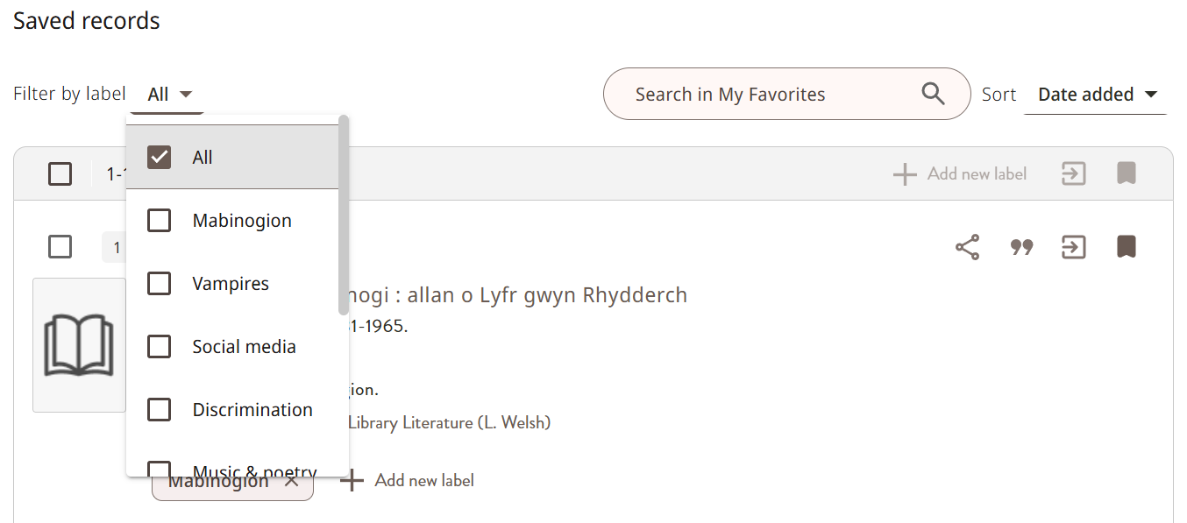

Saved records can also be used to formulate citations or build a bibliography. To cite one item from your list, simply click the speech mark icon displayed by the record. From there you will be given a choice of citation styles. You can then copy and paste your citation into a document.

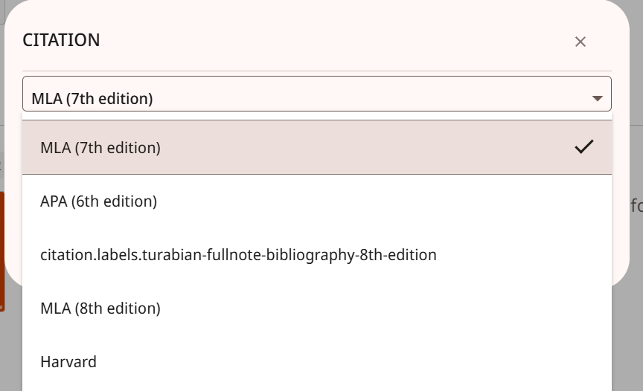

Alternatively, if you would like to build a list or bibliography, you can check the number boxes of the items you wish to list, and then choose from one of the options to the right of the record. The options are (in order from left to right) Share, Cite, Export and Save/Remove from saved records.



If you wish to save a search to your Saved records, click on the Save and Export All Results drop-down menu at the top of the results and choose Save query at the top of your results list.

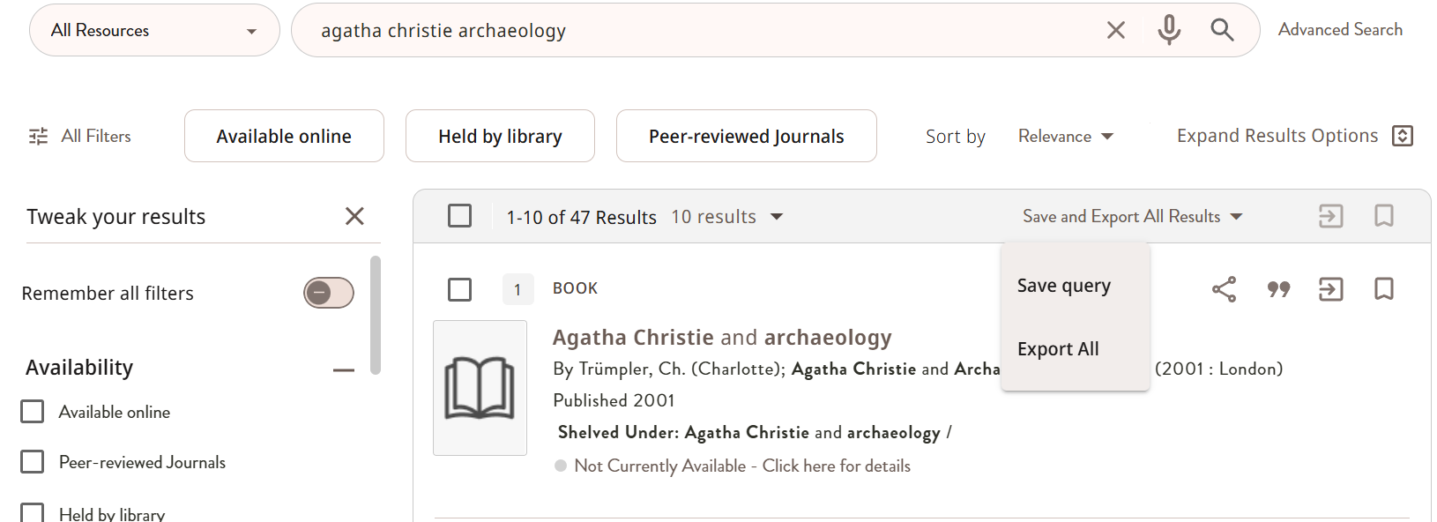

You will be offered the option to turn on notifications for that search and if you choose to do so, you will receive an email when new items that match your search appear on the Catalogue. Saved searches can be found on your Saved records page (in the options on the left-hand side of the screen).

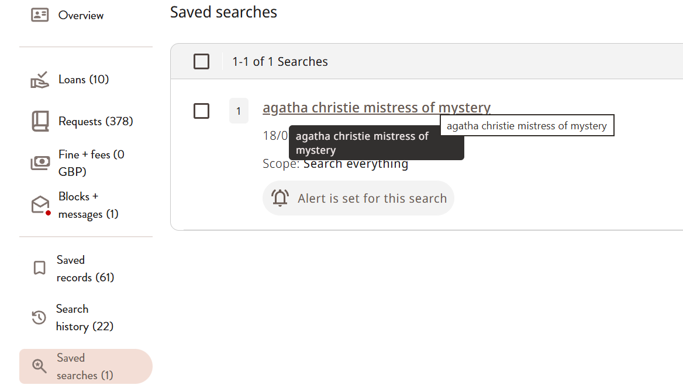

To remove the alert or to delete the saved search, click on the three dots and choose the appropriate option.

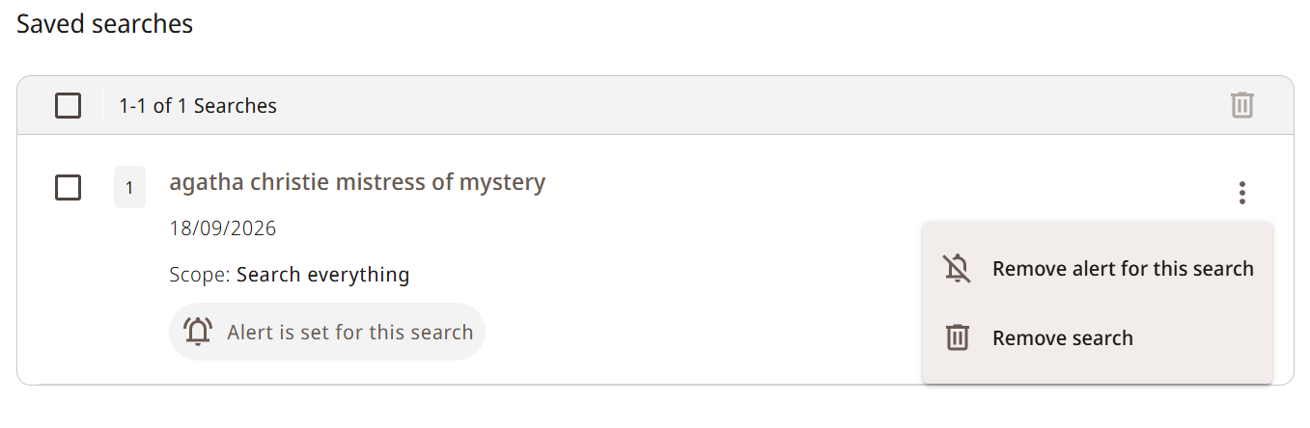

- Accessing online resources

The Catalogue allows members to access London Library online resources both within the Library and remotely using your log-in. Before attempting to access our online resources, always make sure you have signed into the Catalogue, otherwise, your access may be blocked. You can also instruct the Catalogue to only show you results that can be viewed online (Availability); this is particularly useful for Remote Access members and members who may be unable to visit the Library in person.

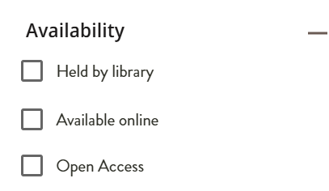

Meanwhile, if you wish to view our online journals, you can click the Ejournals link at the top of the Catalogue homepage.

Type the name of the journal you are looking for in the search bar or browse one of the subject categories from the list on the left-hand side of the screen.

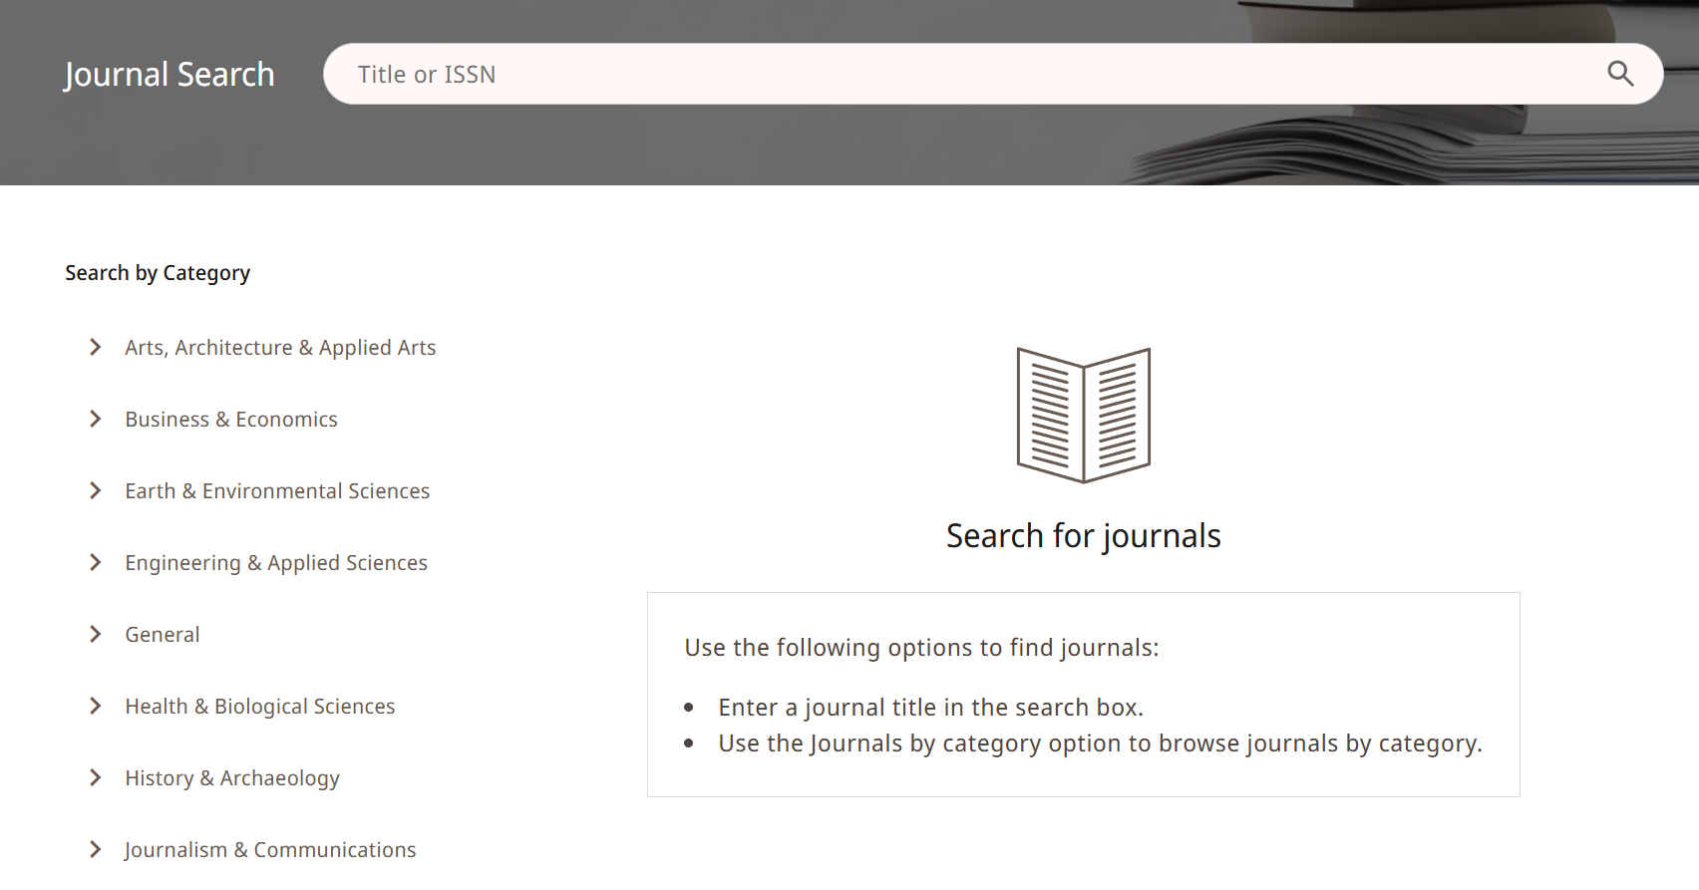

You can also run an ordinary Catalogue search to find online resources that you can access remotely. If you are using the search bar, you can use the Articles or Journals & eJournals search scopes to make sure that you are being shown remote access materials.

Updated September 2026

