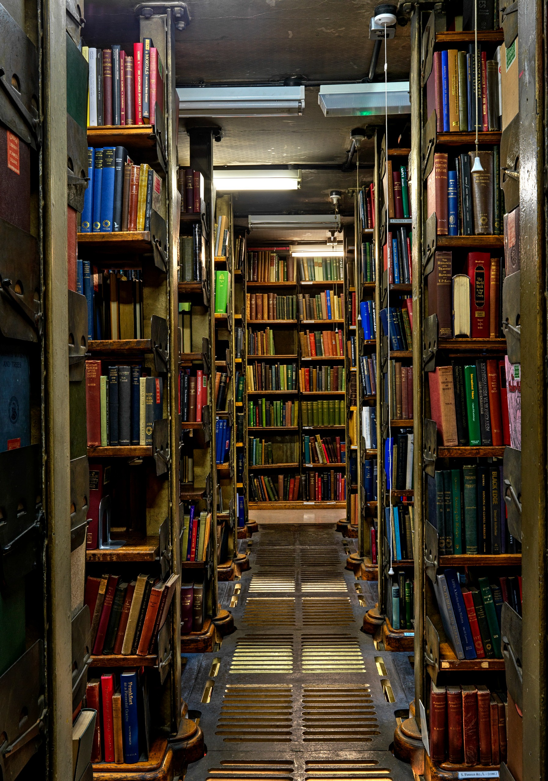
Supported

The London Library 14 St James’s Square London
SW1Y 4LG
londonlibrary.co.uk 020 7766 4720
membership@ londonlibrary.co.uk

Privacy Statement
Membership
The London Library promises to respect and protect any personal data you share with us. Your information is used to administer your membership, personalise your experience of the Library and communications, and provide you with the goods or services you have requested. If you are over 18 we may, in some instances, analyse your data and obtain further publicly available data to help us make our communications more appropriate and relevant to your interests, and anticipate whether you might want to support us in the future. You can opt-out of most communications or the ways in which we process your data by contacting data@londonlibrary.co.uk.
For full details of how we collect, store, use and protect your data, see londonlibrary. co.uk/privacypolicy.
Registered charity no.312175

Supported Membership

Members or prospective members unable to meet the full annual fee of London Library membership may be eligible for Supported membership which will normally cover 30% or, in exceptional cases, 60% of the annual subscription.
Supported members enjoy all of the benefits of Full membership.

Please complete the form below and read our Privacy Statement overleaf.

Name: Title:
Membership no (if current member):
Address:
Postcode:
Telephone:
Email:
Occupation:
Date of birth:
Nature of current studies/use of Library/ project to be pursued:

The Membership
Supported membership is available to applicants who may be pursuing a
course of study, undertaking research, writing a book, or simply needing the Library’s resources for other reasons compatible with its aim of advancing education, learning and knowledge.
The subsidy will normally cover about 30% or, in exceptional cases, 60% of the relevant annual subscription.
The amount and duration of any subsidy provided is at the discretion of the Library.
The Library reserves the right to request evidence of the information provided by the applicant, and to make, vary and withdraw assistance at its discretion and without giving its reasons.

Applications
If you are concerned about affording the full subscription, please complete the form and send it to the Library
at the address overleaf. Applicants who are not already members of the Library should also complete the Library’s membership application form, available on the Library’s website at londonlibrary.co.uk or on request from the Membership Office at the Library. All information will be treated as confidential and will be used only for the purpose of considering the application.
For any further information or advice, please contact our Membership Office at membership@londonlibrary.co.uk or on 020 7766 4720.
Assistance provided under the Supported membership scheme should be acknowledged in any resultant publication, and a copy of that publication presented to the Library on completion.

Approximate gross annual income:
£0 - £5,000 £5,000-£10,000 £10,000-£15,000 £15,000-£20,000
£20,000-£25,000
Details of financial circumstances and responsibilities (e.g. income, dependents):
Likely duration of need:

For Office Use
Granted Y N No of years:
Date:

